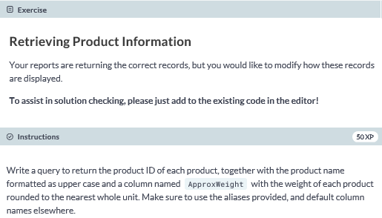

**-- select ProductID and use the appropriate functions with the appropriate columns**

**SELECT ProductID, UPPER(Name) AS ProductName, ROUND(Weight, 0) AS ApproxWeight**

**FROM SalesLT.Product;**

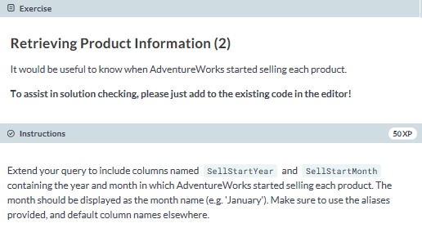

**SELECT ProductID, UPPER(Name) AS ProductName, ROUND(Weight, 0) AS ApproxWeight,**

**-- get the year of the SellStartDate**

**YEAR(SellStartDate) as SellStartYear,**

**-- get the month datepart of the SellStartDate**

**DATENAME(m,SellStartDate) as SellStartMonth**

**FROM SalesLT.Product;**

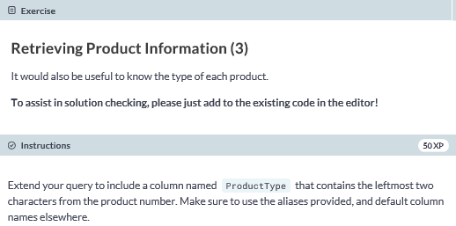

**SELECT ProductID, UPPER(Name) AS ProductName, ROUND(Weight, 0) AS ApproxWeight,**

**YEAR(SellStartDate) as SellStartYear,**

**DATENAME(m, SellStartDate) as SellStartMonth,**

**-- use the appropriate function to extract substring from ProductNumber**

**LEFT(ProductNumber, 2) AS ProductType**

**FROM SalesLT.Product;**

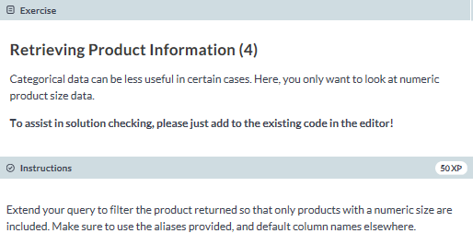

**SELECT ProductID, UPPER(Name) AS ProductName, ROUND(Weight, 0) AS ApproxWeight,**

**YEAR(SellStartDate) as SellStartYear,**

**DATENAME(m, SellStartDate) as SellStartMonth,**

**LEFT(ProductNumber, 2) AS ProductType**

**FROM SalesLT.Product**

**-- filter for numeric product size data**

**WHERE ISNUMERIC(Size) = 1;**

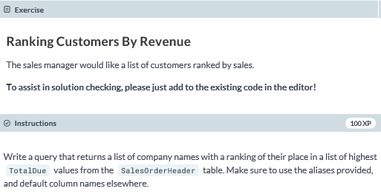

**-- select CompanyName and TotalDue columns**

**SELECT C.CompanyName, SOH.TotalDue AS Revenue,**

**-- get ranking and order by appropriate column**

**RANK() OVER (ORDER BY TotalDue DESC) AS RankByRevenue**

**FROM SalesLT.SalesOrderHeader AS SOH**

**-- use appropriate join on appropriate table**

**JOIN SalesLT.Customer AS C**

**ON SOH.CustomerID = C.CustomerID;**

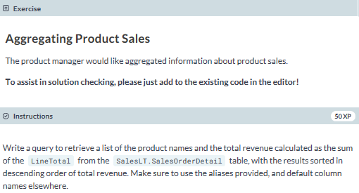

**-- select the Name column and use the appropriate function with the appropriate column**

**SELECT P.Name, SUM(SOD.LineTotal) AS TotalRevenue**

**FROM SalesLT.SalesOrderDetail AS SOD**

**-- use the appropriate join**

**JOIN SalesLT.Product AS P**

**-- join based on ProductID**

**ON SOD.ProductID = P.ProductID**

**GROUP BY P.Name**

**ORDER BY TotalRevenue DESC;**

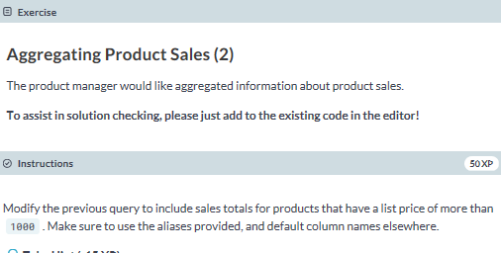

**SELECT Name, SUM(LineTotal) AS TotalRevenue**

**FROM SalesLT.SalesOrderDetail AS SOD**

**JOIN SalesLT.Product AS P**

**ON SOD.ProductID = P.ProductID**

**-- filter as per the instructions**

**WHERE P.ListPrice > 1000**

**GROUP BY P.Name**

**ORDER BY TotalRevenue DESC;**

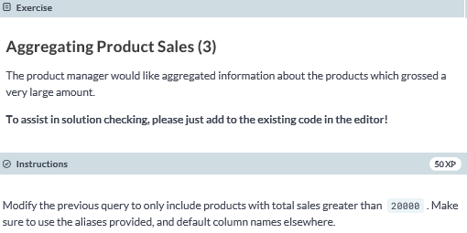

**SELECT Name, SUM(LineTotal) AS TotalRevenue**

**FROM SalesLT.SalesOrderDetail AS SOD**

**JOIN SalesLT.Product AS P**

**ON SOD.ProductID = P.ProductID**

**WHERE P.ListPrice > 1000**

**GROUP BY P.Name**

**-- add having clause as per instructions**

**HAVING SUM(LineTotal)>20000**

**ORDER BY TotalRevenue DESC;**